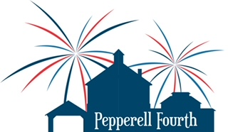
Small Town, Big Bang!
2026 Parade & Event Participant
Release of Responsibility Form

Release Waiver

I/We, the undersigned, our heirs, successors, executors, administrators, next of kin and assigns hereby release the Pepperell 4th of July Committee, Inc., its directors, officers, fundraiser organizers, sponsors, representatives, employees, agents, volunteers, successors and assigns, and anyone affiliated in any way with the Pepperell 4th of July Committee, Inc. from all claims, demands, and causes of action of any kind, civil, or otherwise. This includes, but is not limited to, individual event participation of any kind, volunteers, organizers, sponsors, agents, representatives, chairpersons, treasurers, clerks and others.

I/We, the undersigned, certify that we/I am/are have no mental or physical impairment that would impact my ability to sign or understand this waiver.

I hereby certify that I have read this Waiver in its entirety, and that I have signed it freely and voluntarily, and I acknowledge that the Pepperell 4th of July Committee, Inc. is relying on my execution of this document.

Next Steps: Download, share with all participants, confirm and save for your files.

To confirm: reply to the email received with “I understand and agree to the release waiver, and will distribute to all participants.”

Thank you!

